temp.R

statisticallyfit

Thu Apr 5 07:57:42 2018

setwd("/datascience/projects/statisticallyfit/github/R/RStatistics/STAT210 Statistical Modelling and Experimental Design/")  
source('/datascience/projects/statisticallyfit/github/R/RStatistics/STAT210 Statistical Modelling and Experimental Design/PLOTTING.R')

## Loading required package: grid  
## Loading required package: scales  
## Loading required package: proto

load("data/Exercises and Examples/SOCWORK.Rdata")  
library(ggplot2)  
library(ggfortify)  
options(digits=10)  
  
  
# Now fitting the multiplicative model ln(y)  
social.log.lm <- lm(LNSALARY ~ EXP + I(EXP^2), data=SOCWORK)  
summary(social.log.lm)

##   
## Call:  
## lm(formula = LNSALARY ~ EXP + I(EXP^2), data = SOCWORK)  
##   
## Residuals:  
## Min 1Q Median 3Q Max   
## -0.35490356 -0.09024389 -0.01779821 0.09751477 0.26267100   
##   
## Coefficients:  
## Estimate Std. Error t value Pr(>|t|)   
## (Intercept) 9.842886e+00 8.479351e-02 116.08065 < 2.22e-16 ***  
## EXP 4.969180e-02 1.182345e-02 4.20282 0.00011696 ***  
## I(EXP^2) 9.403863e-06 3.752655e-04 0.02506 0.98011382   
## ---  
## Signif. codes: 0 '***' 0.001 '**' 0.01 '*' 0.05 '.' 0.1 ' ' 1  
##   
## Residual standard error: 0.1557425 on 47 degrees of freedom  
## Multiple R-squared: 0.8635065, Adjusted R-squared: 0.8576983   
## F-statistic: 148.6694 on 2 and 47 DF, p-value: < 2.2204e-16

p1 <- partialPlot(social.log.lm, variableName = "EXP")  
p2 <- partialPlot(social.log.lm, variableName = "I(EXP^2)")  
multiplot(p1, p2, cols=2)

## Don't know how to automatically pick scale for object of type AsIs. Defaulting to continuous

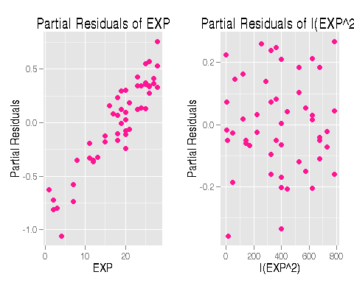

# Questions:   
  
# 1. what does it mean when the first plot is linear with positive slope  
# but the second plot is just scatter?   
# I thought the partial residual plot should show scatter along the  
# line: e* = e + bj * xj, where e* is the partial residual, e = original model  
# residual, Bj-hat = predicted slope in original model, xj = jth predictor.  
# So I am wondering what the second plot means in relation to this line - why  
# does it not follow a line?  
  
# Also, I would like to be able to plot this line at the same time on the graphs  
# shown. What would be the actual line I plot? (Not sure what the intercept  
# should be, but I guess the slope must be Bj-hat?)